BRM, VS2008, IIS and LMe Walkthrough Script

Last updated: December 4, 2009

Preliminary Steps 2

Workflow 4

Step 1: Programmer Makes Changes 4

Step 2: Dev Manager Promotes via LMe 4

Step 3: Build Manager Selects Desired Code for the Build 5

Step 4: Build Manager Imports the Build Package into LM 5

Step 5: Build Manager Promotes and Deploys Build Package via LM 5

## Preliminary Steps

1. Log on to PSG-TS as Don Caps.
2. Start up LMe
3. Start up VS 2008 and open up the VS08_ObjHst Project.
4. Open up Internet Explorer and go to <http://psg-websvr/objhst08/objhst.aspx>
5. If this page doesn’t load
   1. Log on to psg-websvr
   2. Run C:\WINDOWS\system32\inetsrv\inetmgr.exe 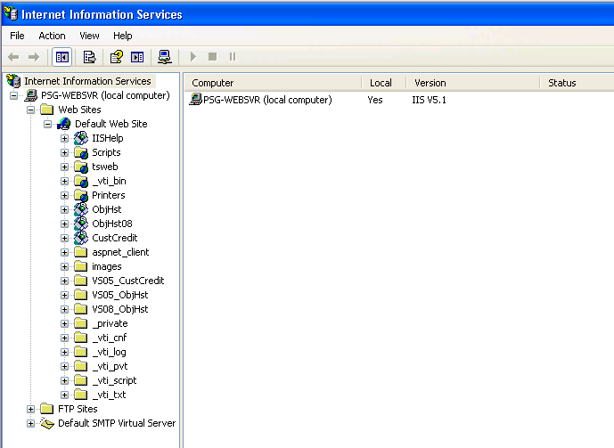
   3. Restart the IIS server 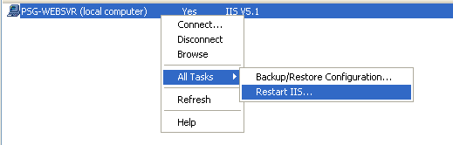
   4. 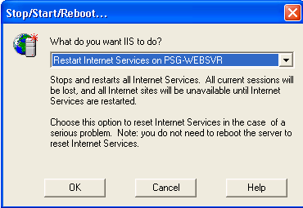
   5. You should check to make sure that the password for joeb_x for AldonM00 is correct. It is stored in the web.config file in the VS2008 project. If it is wrong here, fix it. Also may need to re-enable the user profile if you tried to connect too many times with the wrong password.

## Workflow

1. Programmer opens VS2008 and checks out object from Aldon Repository and checks out code
2. Programmer checks code back in from VS08
3. Build Manager promotes all changes up to production inventory.

LM Repository for VS08_ObjHst

Programmer in VS2008 accesses VS08_ObjHst solution and checks out code.

Web/Visual_Studio/VS08_ObjHst(3.0) regular release to promote

VS2008 Publish the Project to c:\ObjHst_Builds

Import into LM Web/Visual_Studio/ObjHst_Releases(3.5)

1

2

3

4

5

## Step 1: Programmer Makes Changes

1. From VS2008, access solution for VS08_ObjHst
2. RC on ObjHst.apsx in the project and select checkout
3. Select Advanced drop down and look for TASK73 under VS08_ObjHst project.
4. DC on ObjHst.aspx and change the title of the page.
5. Check it back in from VS.

## Step 2: Dev Manager Promotes via LMe

1. Switch over to LMe
2. Drill into Web\Visual_Studio\VS08_ObjHst(3.0)
3. Show the objects checked in and now in QA..no deployment
4. Switch to view by location and move all items into production inventory.

## Step 3: Build Manager Selects Desired Code for the Build

1. At some point, the Build Manager decides it is time to create a build of the changed code.
2. Return to VS2008.
3. RC on the project at the c...\VS08_ObjHst project
4. Select Publish Web Site
5. Publish it to C:\ObjHst_Builds
6. Watch the lower left hand corner until you see “Publish Successful”. This replaces the old build in the folder with the new one.

## Step 4: Build Manager Imports the Build Package into LM

1. Navigate to C:\buildscript\ObjHst
2. DC on build_script.bat

## Step 5: Build Manager Promotes and Deploys Build Package via LM

1. Open LMe to the Web\Visual_Studio\ObjHst_Releases(3.5) Build Release
2. Show how the package has arrived in the IMP stage.
3. RC and show properties
4. RC and promote to QUA, no deployment here.
5. RC and Request Promote (required by my config)
6. RC and promote to PDN, with deployment
7. Show deployment set, and target, and files deployed
8. Return back to IE and refresh page to show changes
9. Show archives, rollbacks, history logs, CM tracks as desired